**Lab 3: MOTION CONTROL**

***Gabe Moreno, Luke Morgan, James Kan, and Amari West***

**Texas A&M University**

College Station, TX 77843, US.

***Abstract*** *This report covers the application of Newton’s second law as well as calculating the gravitational constant given kinematics equations through a spaceship simulation. Numbers were plugged into kinematics equations in order to discover the value for the gravitational constant of acceleration as well as the force of thrust. Once a force of thrust was calculated from physics equations, it was input into the simulation where a speed under 10 km/s would be the result of the spacecraft. This exercise provided an application for Newton’s second law as well as a control of motion.*

***Keywords:*** *acceleration, velocity, force, thrust*

1. **Introduction**

The goal of this lab was to find the gravitational constant of acceleration. This was to be done through running a simulation of a spacecraft and freefall. The second part of the experiment required an input thrust force that would allow the simulated ship to land within a certain range of velocity.

The physics concepts used to find the initial acceleration for the simulated spacecraft, the gravitational constant, was the rearranged kinematics equation, v^2fg=v^2o+2gxt. Then, Newton’s second law, F = ma was used in order to find the thrust value needed in order to allow the ship to fall within the speed range. These concepts would lead to the values calculated for the gravitational acceleration and force of thrust.

1. **Experimental Procedure** (see [here](https://tamu.blackboard.com/bbcswebdav/pid-6307302-dt-content-rid-58666344_1/courses/ENGR.216.2011.M4/216_lab3.pdf) for complete and specific instructions)

A personal laptop with a Linux Secure Shell Terminal (e.g. MobaXterm) and an ethernet connection was required to capture the data and the recording of the experiment. Once connected and activated, the required terminal commands, and other commands needed in order to capture and record the data acquired from the camera were inputted.

The procedure to determine the gravitational acceleration of the asteroid is as follows:

1. First, the spacecraft was subject to the acceleration of the asteroid without any thrust. The program then returned the speed of impact of the spacecraft on the asteroid. With this value and the fact that the spacecraft started at rest, the gravitational acceleration of the asteroid was able to be determined using the formula v2 - v2o = 2a(Δx).
2. With the gravitational acceleration of the asteroid determined, the thrust needed for the spacecraft to safely land on the asteroid in the predetermined range was able to be calculated using a variety of kinematic equations:
   1. First, the velocity of the spacecraft after the 32 km free fall was determined using the equation

v2 - v2o = 2a(Δx).

* 1. Next, the net acceleration needed to slow the aircraft to a final velocity of 0 km/s at the surface of the asteroid was determined using the equation v2 - v2o = 2a(Δx).
  2. Then, the force due to thrust exerted by the aircraft was determined using the equation

Fnet = Fgravity + Fthrust along with the equation F = ma.

* 1. The process was then repeated to calculate the thrust needed to decelerate the spacecraft to 10 km/s to find the safe range of thrusts acceptable.

1. **Results and Analysis**

When the raw data is obsvered, the motion that the spacecraft exhibited along the x and y coordinates demonstrates that a smooth landing had taken place, especially when the velocity was directly plotted with the distance from the asteroid. However, due to the technical limitations of the camera, there was a noisey inconsistancy with the data as random errors were included with the velocity and acceleration calculations. In addition, the graphs record the motion of the spacecraft for only a fraction of the entire simulation run-time. All data cut out of the graphs included the motion of the rocket as the simulation perpared its initial position and the motion of the rocket as it returned to a resting state as the simulation ended.

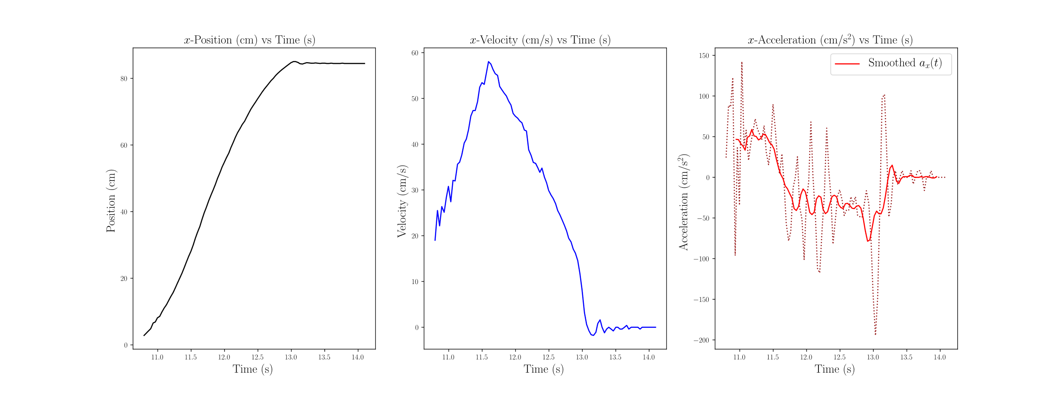

Figure 1: Position, Velocity, and Acceleration along the x-axis

As seen in Figure 1, rocket started 80 cm away from the asteroid with an acceleration, aided by gravity, towards the asteroid. As the position approached 48cm from the asteroid, the rocket began to apply its trust of about 240 newtons in the negative direction, slowing its decent towards the asteroid. Once the rocket made contact with the asteroid, the rocket’s velocity was within the threshold required to engage in a safe landing.

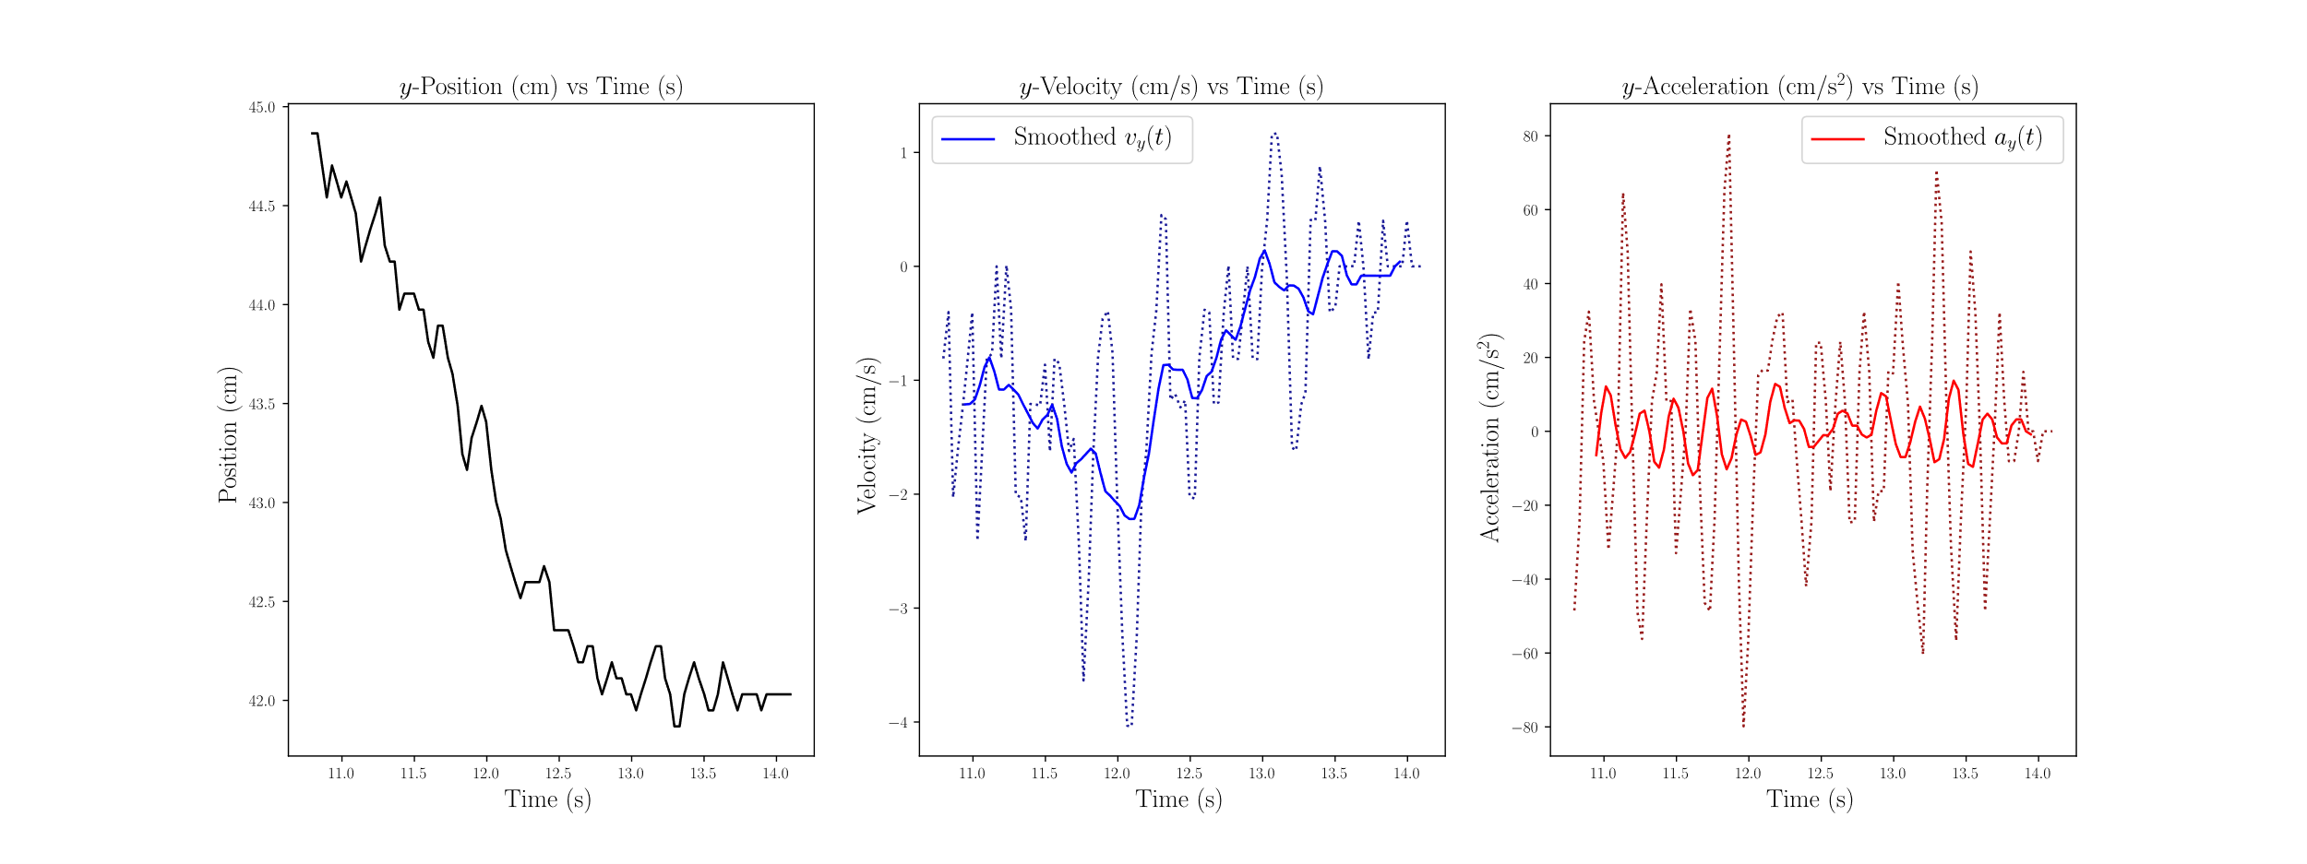

Figure 2: Position, Velocity, and Acceleration along the y-axis

The motion of the spacecraft along the y-axis wasn’t at all critical, as it had nothing to do with the calculation of $g$, or gravitational acceleration; however, as Figure 2 shows, it illustrates how random errors in the simulation capturing process can skew and manipulate results. The original expectation no change in position, meaning no velocity or acceleration, but the camera’s tracking system showed otherwise even if the skew was negatable overall.

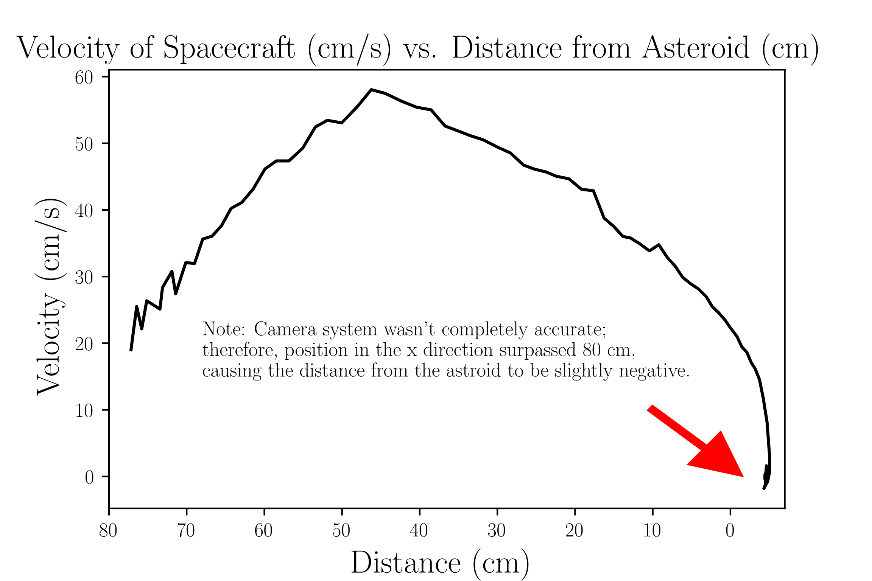

Figure 3: Velocity of the Spacecraft Against Its Distance

Figure 3 showed how the velocity changed as the spacecraft fell closer to the asteroid. In a scenario of a optimal landing, the velocity should be close as possible to zero just as the distance reaches zero, or in the case of the simulation, at least less than 10 cm/s. Figure 3 provided the best illustration that the spacecraft had a safe landing, by explicitly demonstrating that the spacecraft had an almost-zero velocity as it touched the asteroid’s service as seen where the red arrow on the figure points.

Based on the data that came from the graphs and the values that were given as shown:

$m=291 kg$, $x_{t}=80 km$, $x_{1}=32 km$, $x_{2}=48 km$, $v_{f}=10 or 0 km/s$, $v_{fg}=888 km/s$ (given)

The gravitational constant, the initial velocity, and the acceleration was calculated using the following equations.

$$g = \frac{v_{fg}^{2}}{2⋅x_{t}} = 49.284 cm/s^{2}$$

$$v_{i} = \sqrt{2⋅g⋅x_{1 }}=56.162 cm/s$$

$$a_{net}=\frac{\left(v_{f}^{2}-v_{i}^{2}\right)}{2⋅x_{2}}=-31.8143 cm/s^{2}$$

Moreover, the following shows the calculated and experimental values for the maximum and minimal amount of acceptable thrust needed to engage in a safe landing.

$a_{t}=\left(\left|a_{net}\right|+\left|g\right|\right)=82.14 cm/s^{2}$; $235.996 \{239\} ≤F_{t} ≤239.03$ {242}, {experimental values}

1. **Conclusions**

The process used to find these values demonstrated how Newton’s Second Law, used with the standard kinematic equations, can find the magnitudes of unknown forces as well as illustrate how forces affect the position, velocity, and acceleration of an object. The final calculation for g was 49.284 ± 3.9250 $cm/s^{2}$, and in order to successfully land the spacecraft, an upward thrust between 239 N and 242 N had to be applied to the spacecraft. All error calculations were found using standard deviation and general formulas for error propagation.